**SUB SPACE**

Definition:

If *V* is a vector space over a [field](https://en.wikipedia.org/wiki/Field_(mathematics)) *K* and if *W* is a subset of *V*, then *W* is a subspace of *V* if under the operations of *V*, *W* is a vector space over *K*. Equivalently, a [nonempty](https://en.wikipedia.org/wiki/Empty_set) subset *W* is a subspace of *V* if, whenever *w*1, *w*2 are elements of *W* and a,b are elements of K then it follows a*W*1 + b*W2 is in W.*

Concept:

If W is a non empty subset of a vector space V then W is a subspace of V if:

1. For all u and v in W,u+v is also in W
2. For any scalar k and a vector u of W, ku is in W.

Method:

1. Show it is closed under addition.
2. Show it is closed under scalar multiplication.
3. Show that the vector 0 is in the subset.

`

Examples:

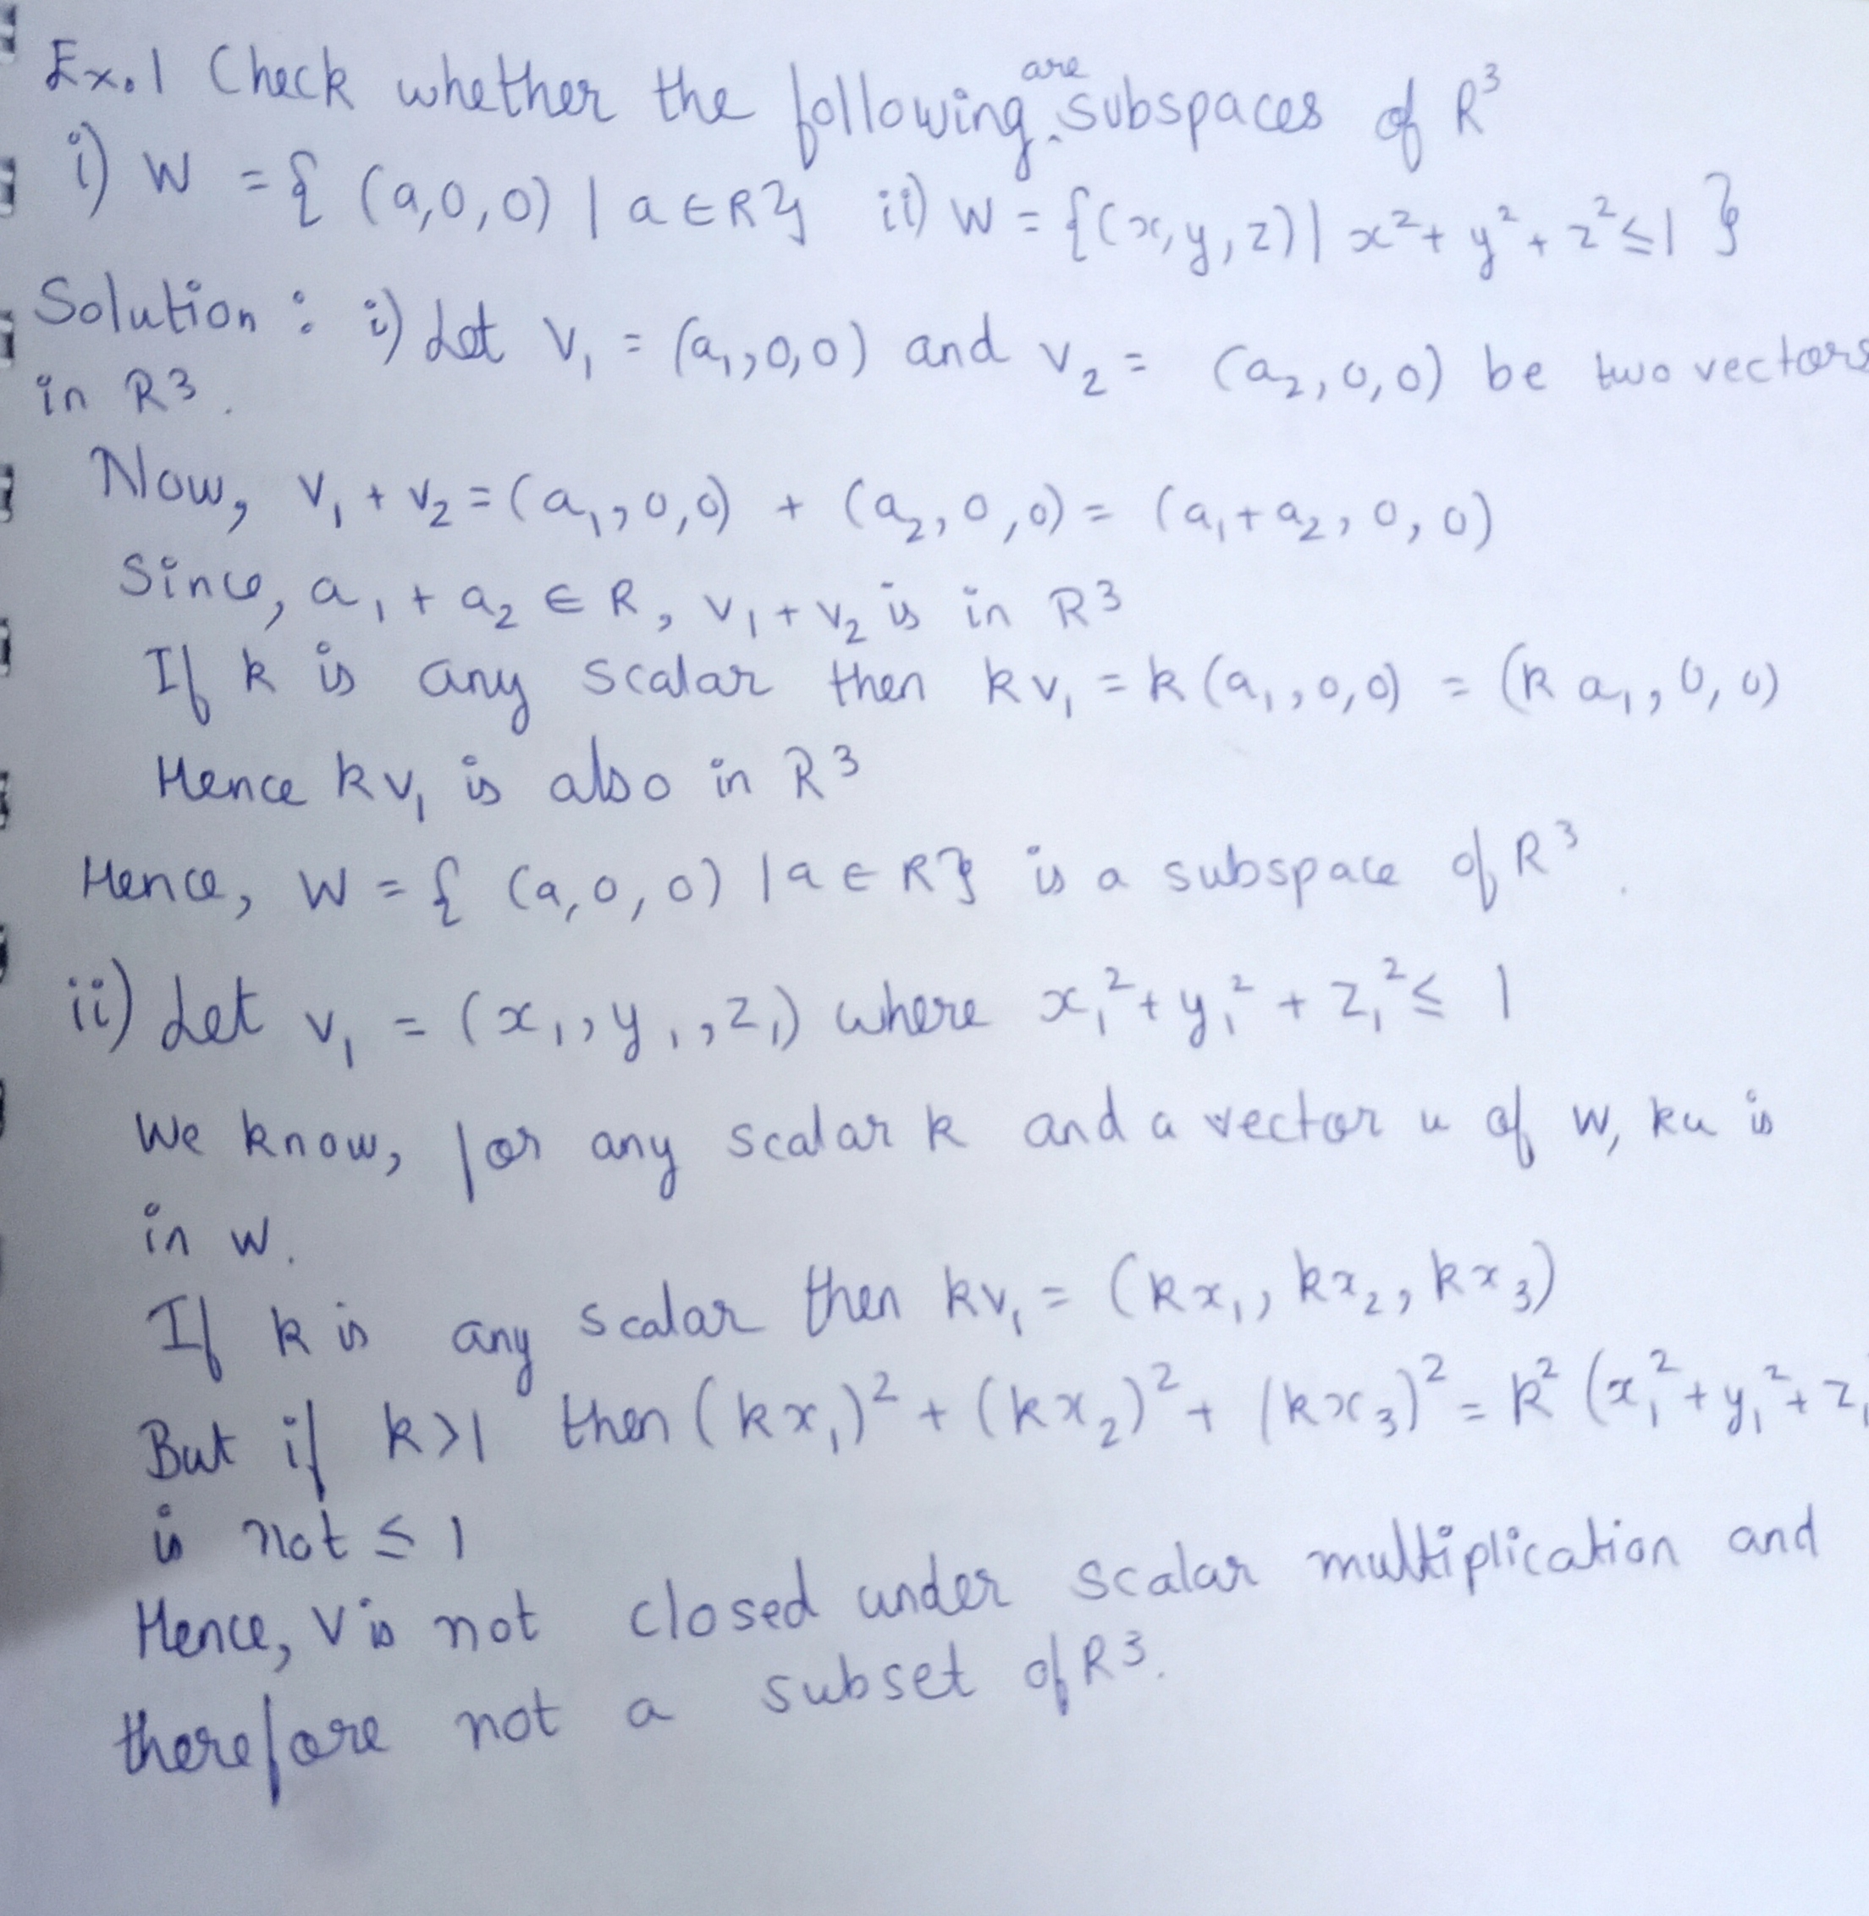

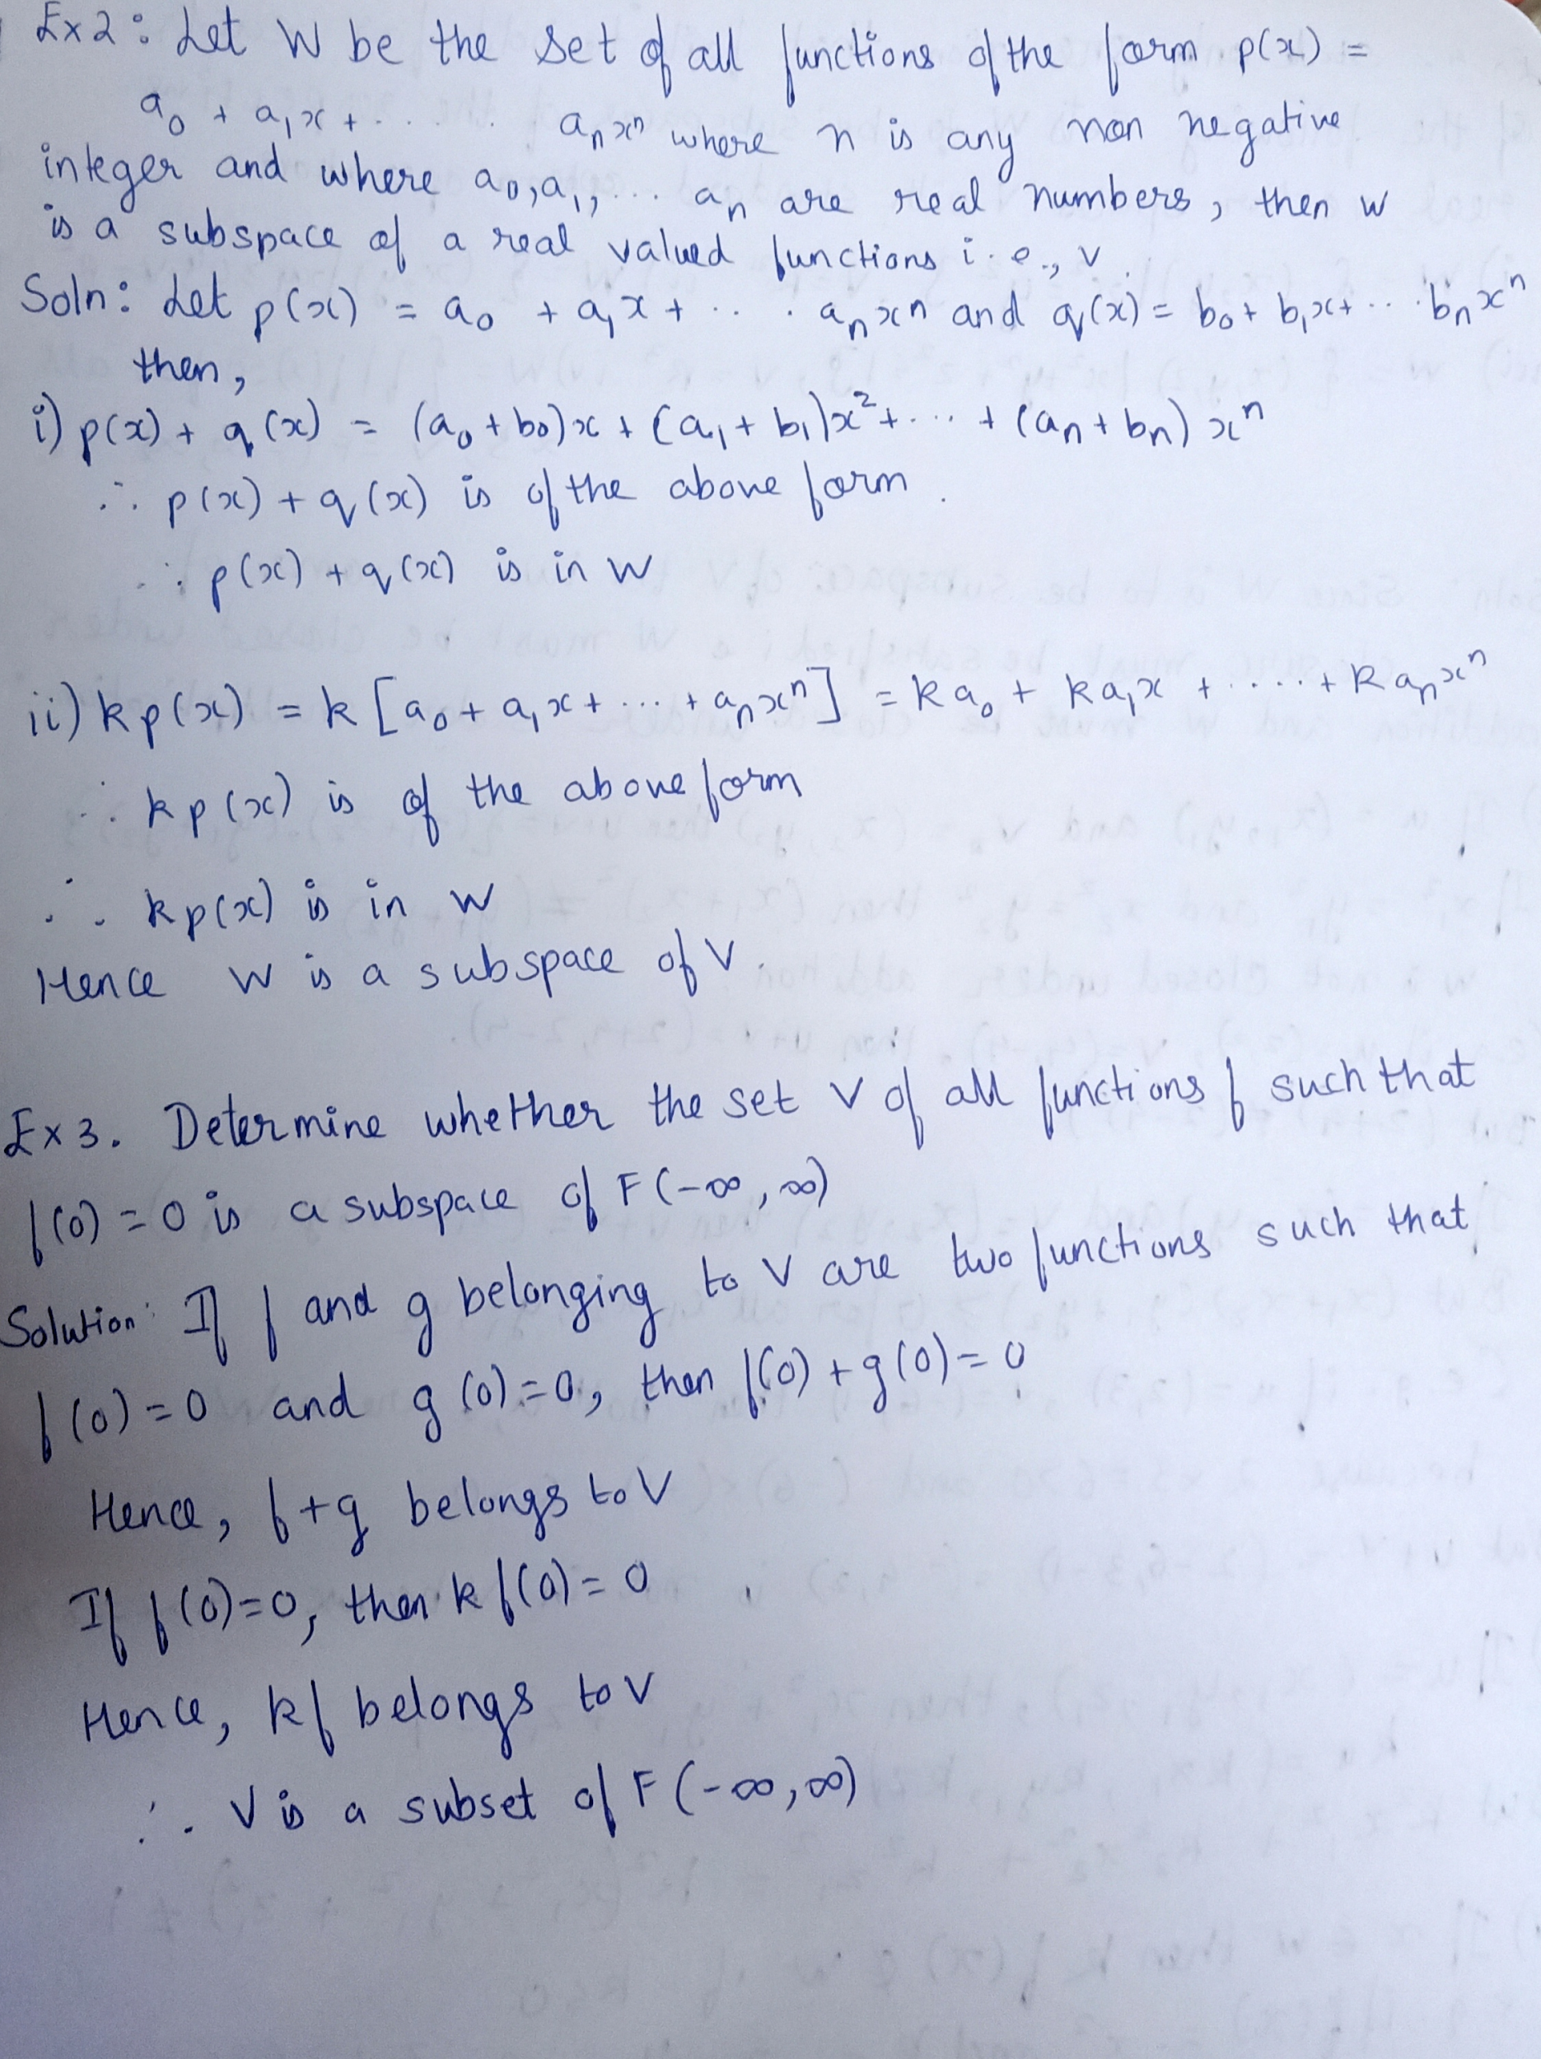

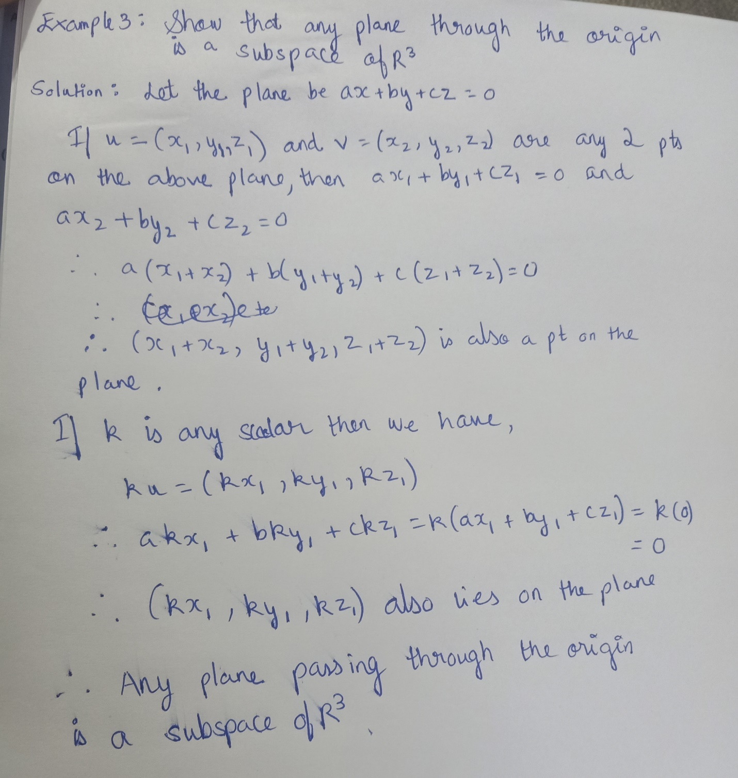

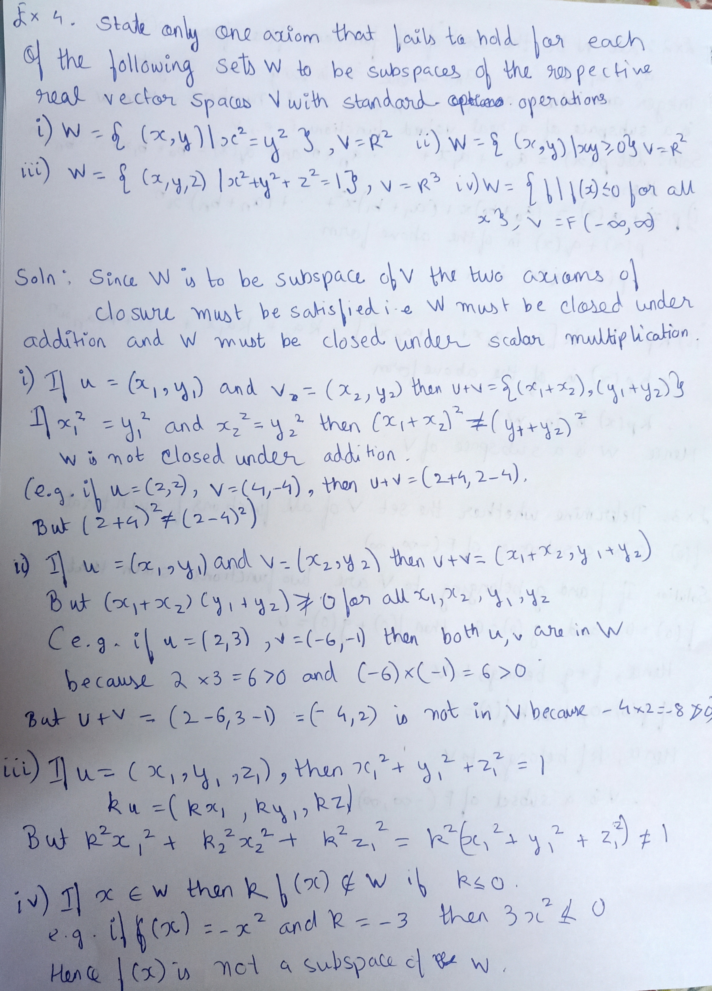

Application:

The theory of subspaces of n spaces is applied in the study of approximations. For example, whether a smooth real function can be approximated to a given level of accuracy by step functions or polynomial functions or trigonometric functions can be studied.

Significance:

A subspace is a vector space that is entirely contained within another vector space. As a subspace is defined relative to its containing space, both are necessary to fully define one.